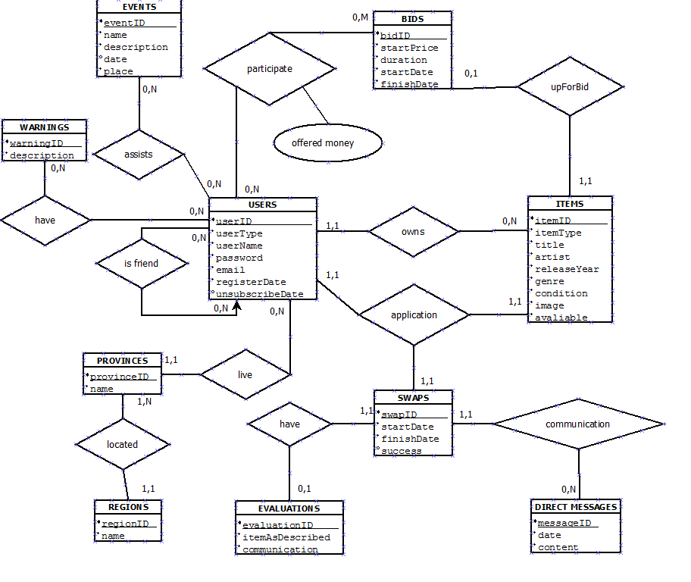**Relational Model**

Conversionfrom E-R to Relational:

**PK** **FK PK&FK**

**USERS** (**userID(PK)**, **regionID(FK)**, userType, userName, password, email, registerDate, unsubscribeDate)

**PROVINCES** (**provinceID(PK)**, **regionID(FK)**, name)

**REGIONS**(**regionID(PK)**, name)

**EVENTS**(**eventID(PK)**, name, description, date, place)

**GENRES**(**genreID(PK)**, name)

**CONDITIONS**(**conditionID(PK)**, name)

**ITEMS**(**itemID(PK),userID(FK)**, **bidID(FK),**itemType, title, artist, releaseYear, **genreID(FK)**, **conditionID(FK)**, image, avaliable)  
**BIDS** (**bidID(PK),itemID(FK),**startPrice, duration, startDate, finishDate)

**WARNINGS**(**warningID(PK)**, description)

**EVALUATIONS**(**evaluationID(PK)**, **swapID(FK)**,itemAsDescribed, comunication)

**SWAPS**(**swapID(PK)**, **evaluationID(FK),** startDate, finishDate, succes)

**DIRECT_MESSAGES**(**messageID(PK)**,**swapID(FK)**, date, content)

**EVENTS_ASSISTANCE**(**userID(PK&FK)**, **eventID(PK&FK)**)

**BIDS_PARTICIPATION** (**userID(PK&FK)**, **bidID(PK&FK)**, offeredmoney)

**WARNING_USERS**(**warningID(PK&FK)**,**userID(PK&FK)**)

**FRIENDS**(**userID(PK&FK)**,**friendID(PK&FK)**)

**APPLICATIONS** (**userID(PK&FK)**,**swapID (PK&FK)**, **itemID(FK)**)